DEU Computer EngIneerIng
CME2002
Data Organızatıon
&
Management

Lab 2 – XML Attrıbute parsıng, JSON READıng & wrıtıng
Assoc. Prof. Dr. Adil ALPKOÇAK
DR. Mete Uğur AKDOĞAN
Mansur Alp TOÇOĞLU
Mehmet cengiz

XML attrıbute HANDLING
IntroductIon
In this lab session, you will primarily learn how to read attributes in XML files in C. We will be using libxml2 library for this purpose. First we will see how to set up this library so you can do it on your own computers as well.

lIbxml2

Step 1: Setup of libxml2

This library can be easily installed with the package manager. But for our Debian distributions we first need to update our package list with the following command:

sudo apt-get update

After updating the packet list, we can install the library with this command:

sudo apt-get install libxml2-dev

By default the library is setup under the following directory:

/usr/include/libxml2/libxml

XML in Practice

Step 2: Run the XML parse code.

Below is a code snippet that reads an XML file, parses it and prints an output. Note that the code tires to read from a XML file named note.xml that is under the same folder with the code. Copy that code to a file named parse.c, fill the blanks, compile and run it. Inspect the output carefully. In order to compile a file, you have to include the following path:
-I/usr/include/libxml2 -lxml2.

#include <stdio.h>
#include <libxml/parser.h>
#include <libxml/tree.h>

static void print_element_names(xmlNode * a_node);

int main()
{
xmlDoc *doc = NULL;
xmlNode *root_element = NULL;
const char *Filename = "note.xml";
doc = xmlReadFile(Filename, NULL, 0);

if (doc == NULL)
{
printf("error: could not parse file %s\n", Filename);
}
else
{
/* Get the root element node*/
root_element = xmlDocGetRootElement(doc);

print_element_names(root_element);

/*free the document*/
xmlFreeDoc(doc);
}
/*Free the global variables that may have been allocated by the parser.*/
xmlCleanupParser();

return (0);
}
/* Recursive function that prints the XML structure */

static void print_element_names(xmlNode * a_node)
{
xmlAttr *attributes = NULL;
xmlNode *cur_node = NULL;
for (cur_node = a_node; cur_node; cur_node = cur_node->next) {
if (cur_node->type == XML_ELEMENT_NODE) {
printf("Node Type: Element, name: %s \n Its children's type is: %d \n Its children's content is: %s \n children name:%s \n", cur_node->name, cur_node->children->type, cur_node->children->content,cur_node->children->name);
attributes = cur_node->properties;
while(attributes)
{
//display names and values of the attributes
printf("%s:%s\n",....... , .......);
attributes = attributes->next;
}

}
print_element_names(cur_node->children);
}
}
Below you can see the xmlNode structure and xmlElementTypes enumarations.
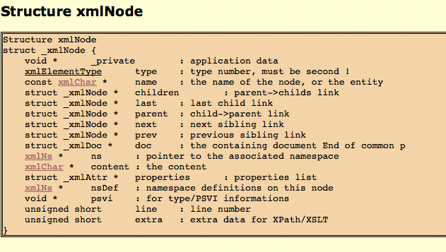
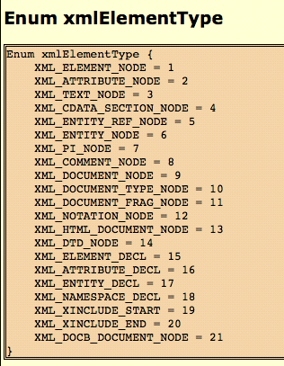

JSON
JSON is a data inter-exchange format. When compared to XML, it is very lightweight and more human-readable.
JSON represents the data as key:value pairs, where the value can be string, numbers, arrays, boolean values or even null value.
It is nowadays very heavily used data format for data transfer in the web. Most languages like PHP have functions to manipulate JSON data. In case of C/C++, there are many libraries like json-c, json-glibc, jsoncpp.

How to Install Json-C in Linux
json-c is a C library for manipulating JSON data in C/C++. You can execute the following command to install json-c library to Debian.

sudo apt-get install libjson0 libjson0-dev

Compiling a json-c program in Linux
To compile the program, we must use the “-l” option with the library name “json“. This helps in dynamic loading of the library libjson.

gcc program.c -o program -ljson -std=c99

1. JSON Parsing
#include <json/json.h>
#include <stdio.h>

void json_parse(json_object * jobj) {
enum json_type type;
json_object_object_foreach(jobj, key, val) {
type = json_object_get_type(val);
switch (type) {
case json_type_string:
printf("type: json_type_string, ");
printf("value: %s\n", json_object_get_string(val));
break;
}
}
}
int main() {
char * string = "{ \"site\" : \" coding\", \"purpose\" : \" tips\", \"platform\" : \"temp\" }";
printf ("JSON string: %s\n", string);
json_object * jobj = json_tokener_parse(string);
json_parse(jobj);
return 0;
}

Copy-paste the above code to “simplej.c” and compile with
gcc simplejson.c -o simplejson -ljson -std=c99
./simplejson

json_object_object_foreach is a macro defined something like this

Copy-paste the above code to “simplej.c” and compile with
gcc simplejson.c -o simplejson -ljson -std=c99
./simplejson

json_object_object_foreach is a macro defined something like this

#define json_object_object_foreach(obj,key,val)
char *key; struct json_object *val;

A json object can have any of the following types
- null
- boolean
- double
- int
- object
- array
- string

json_object_get_type() gives you the type of every object.
enum json_type json_object_get_type(struct json_object *this);

It accepts a json_object and returns the type of the json object. The values can be
- json_type_boolean
- json_type_double
- json_type_int
- json_type_object
- json_type_array
- json_type_string

Task 1
Modify the previous code, so that it gives the output below:
JSON string: { "id" : 10, "name" : "Ali", "surname" : "Veli", "gpa" : 3.22, "repeat" : false }
type: json_type_int, key: id, value: 10
type: json_type_string, key: name, value: Ali
type: json_type_string, key: surname, value: Veli
type: json_type_double, key: gpa, value: 3.220000
type: json_type_boolean, key: repeat, value: false

Your Code:

2. Creating a New JSON Object
json_object_new_object is used to create a new json object. Once you create a json object, you can add more objects to it.
The syntax of the function is
json_object * json_object_new_object ()

As you can see, it returns a pointer to the json object.

2. Creating a New JSON Object
json_object_new_object is used to create a new json object. Once you create a json object, you can add more objects to it.
The syntax of the function is
json_object * json_object_new_object ()

As you can see, it returns a pointer to the json_object.

The following program shows the usage of the function
#include <json/json.h>
#include <stdio.h>

int main() {
/*Creating a json object*/
json_object * jobj = json_object_new_object();

/*Creating a json string*/
json_object *jstring = json_object_new_string("Ali Veli");

/*Creating a json integer*/
json_object *jint = json_object_new_int(20);

/*Creating a jsonboolean*/
json_object *jboolean = json_object_new_boolean(1);

/*Creating a json double*/
json_object *jdouble = json_object_new_double(3.84);

/*Creating a json array*/
json_object *jarray = json_object_new_array();

/*Creatingjson strings*/
json_object *jstring1 = json_object_new_string("c");
json_object *jstring2 = json_object_new_string("c#");
json_object *jstring3 = json_object_new_string("java");

/*Adding the above created json strings to the array*/
json_object_array_add(jarray, jstring1);
json_object_array_add(jarray, jstring2);
json_object_array_add(jarray, jstring3);

/*Form the json object*/
/*Each of these is like a key value pair*/
json_object_object_add(jobj, "Name", jstring);
json_object_object_add(jobj, "Alive", jboolean);
json_object_object_add(jobj, "GPA", jdouble);
json_object_object_add(jobj, "Age", jint);
json_object_object_add(jobj, "Skills", jarray);

/*Now printing the json object*/
printf ("The json object created: %s\n",json_object_to_json_string(jobj));

}

Task 2
Modify the previous code to get the output:
The json object created: { "Name": "Ali Veli", "Age": 19, "Address": { "Country": "Türkiye", "City": "İzmir", "Province": "Buca" }, "Parents": [ { "Mother": "Ayşe" }, { "Father": "Mehmet" } ] }

Your Code:

